Place Your Title Here, in Bold, Using Initial-Capitals, 12 Point

Place author name(s) here, and here, and here
Place your company name here
Place your company address here
email, phone, etc, as desired

Abstract
Place abstract here: usually a single paragraph summarizing the problem, approach, and results that are in the paper. Print out these instructions before pasting your paper’s text into this document, so you can refer back to it. Your manuscript must be between 4 to 8 pages long.

Section Header 1
A statement of the problem or situation, and the approach that is taken to resolve it. The second paragraph in the Section should start with a “line break” (using the enter/return key), but do not add an extra blank line. The slight indent will clearly define the paragraphs, and the “EPTC Text” Style includes a slight spacing (1 point) between paragraphs within the Section.
This first Section may also contain a summary of the past developments and background of what is already known, and published elsewhere. This is best summarized in your own paper, with references to other publications containing more-extensive discussions of this background information. [1] The references are placed at the end of the paper. [2]
Remember that you should not re-state material that is readily available in the archival literature; simply summarize it, then add a reference or two. Many peer-reviewed papers in our fields have been published in the IEEE Transactions on Components and Packaging Technologies, and on Advanced Packaging – see www.cpmt.org/trans/.

Section Header 2
Describe the methodology you have used in this work. You should use the pre-formatted “styles” in the Word toolbar above: type the Section Header, then select “EPTC Section Header” style, above; your Header text will change to Bold and be left-justified, with spacing added above and below it. Then hit enter/return; this will automatically place you in the “EPTC Text” style/format for typing the text paragraphs for that Section. Or, type the text for the section, select all the paragraphs, and choose the “EPTC Text” style, above.
Perhaps you have already prepared your manuscript as a document in Word or in another Word Processor. You may then copy and paste existing headers and text into this Word document, then select the Title, Authors, Section Headers, and Text areas and apply the appropriate Style, from the “EPTC” Styles provided. Look up the word “style” in the Help system for guidance.
If you have difficulty with the spell-checker in WORD, you might select Tools/Language/Set Language. Verify that it is set to English, and that the checkbox at the bottom of the window (“Do not check spelling or grammar”) is unchecked.
Your figures and diagrams, if computer-generated, should be placed at the center of the text with the captions below them as shown in Fig. 1. These figures may have been created in a spreadsheet or graphics program; you should simplify them so that they are easily readable and reduce them to fit into one column (or make them wider, if needed, with text from the second column flowing around them). Figures should be numbered consecutively and given suitable headings. The resolution of the figures should be at least 300 dpi and not more than 600 dpi.

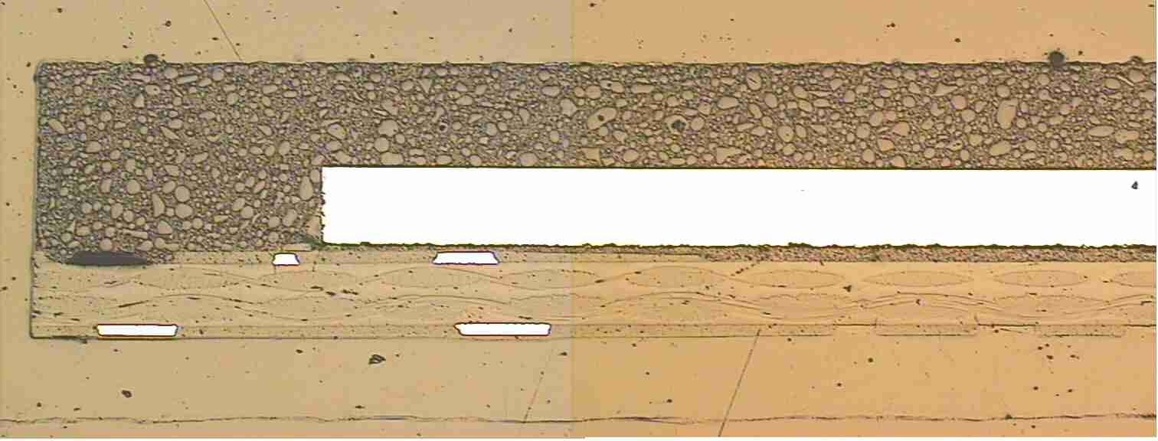

Fig. 1. Typical interface failure

Note that “Fig.” is abbreviated. There is a period after the figure number, followed by two spaces. It is good practice to explain the significance of the figure in the caption.

Table 1. Package reliability result.
No | Test Description | Reliability Result
1 | MST L3 85°C/60% RH with 3IR reflow 260°C based on J-STD-020
2 | Temperature cycling condition B –40 to 125°C for 1000 cycles based on EIA/JESD22-A105-B
3 | Thermal Shock Condition D –65 to 150°C for 700 cycles based on JESD22-A106-A
4 | Accelerated Moisture Resistance – Unbiased autoclave condition C 121°C/100% RH 96hrs based on JESD22-A102-B

Your tables, if computer-generated, should be placed at center of text with text description above them as shown in Table 1. These figures may have been created in a spreadsheet or graphics program; you should simplify them so that they are easily readable and reduce them to fit into one column (or make them wider, if needed, with text from the second column flowing around them. Tables should be numbered consecutively and given suitable headings. Tables should not duplicate results presented elsewhere in the manuscript (for example, in graphs).

Now, for the digital version of your paper, we prefer to have color figures and graphics, where appropriate; these will be viewable in color through the Acrobat Reader, but you should assure that they will be understandable when printed on a B&W printer. Be cautious especially of colors such as yellow, light blue, etc.
Your text should flow completely to the foot of the page. If you are using A4 paper, the left and right margins are set to 13.8 mm, and top and bottom to 25.2 mm. The gutter between columns should already be about 5 mm; it can be set under Format/Columns.
If you are using 8.5x11” paper, then you may need to adjust the margins in this template file. The top of your title (and the top line on each succeeding page) should be 0.67” from the top, and the columns should continue to within 0.67” of the bottom. Th left and right margins should also be set to 0.67”. In “Page Setup”, select “paper size” of Letter; then select “Margins” and set to these values.
See the Format Specification sheet for additional details.

Section Header 3

Describe the results of your study followed by discussions. Add more sections if preferred.

Conclusions
Place conclusions here.

Acknowledgments
Place acknowledgments here, if needed.

References
1. Downey, D. F., Ion Implantation Technology, Prentice-Hall (New York, 1993), pp. 65-67. [A book reference …]
2. Wasserman, Y, “Integrated Single-Wafer RP Solutions for 0.25-micron Technologies,” IEEE Trans-CPMT-A, Vol. 17, No. 3 (1995), pp. 346-351. [A reference to a journal article …]
3. Shu, William K., “PBGA Wire Bonding Development,” Proc 46th Electronic Components and Technology Conf, Orlando, FL, May. 1996, pp. 219-225. [A reference to a presentation at a Conference…]

Version 230726

